3/15/2024

Food Waste reduction platform

Xiaolin Wu

Yingchun Gao

Chunhua Li

Contents

**1. Version History** 3

**2. Introduction** 4

**3. Targeted Audience** 5

**4. Scope** 6

**5. Application Architecture** 7

5.1 Presentation Layer 7

5.2 Business Layer 7

5.3 Database Layer 7

**6. Business Architecture** 9

6.1 Retailer Use Cases: 9

6.2 Charitable Organization Use Cases: 9

6.3 Consumer Use Cases: 10

6.4 Visitor Use Cases 12

6.5 Visitor Use Cases 12

6.6 Visitor Use Cases 13

**7. Detailed Design** 15

7.1 Class diagrams 15

**8. Data Architecture** 16

8.1 Database Structures 16

**9. Security Architecture** 17

9.1 Strong Password Policies 17

9.2 Session Management 17

**10. Testing Model** 18

10.1 Testing Approach 18

10.2 Tools 18

**11. References** 19

References 19

**12. Acronyms/Abbreviation** 20

Figure 1 Application architecture diagram 8

Figure 2 Food retail use case diagram 9

Figure 3 Charitable organization use case diagram 10

Figure 4 Consumer use case diagram 11

Figure 5 Visitor use case diagram. 12

Figure 6 Visitor use case diagram 13

Figure 7 Visitor use case diagram 14

Figure 8 Class diagram 15

Figure 9 ERD of Food Waste Reduction System 16

Table 1 Version History 5

# **Version History**

Table 1 Version History

|  |  |  |
| --- | --- | --- |
| Version # | Author | Date |
| 1.0 | Chunhua Li  Yingchun Gao  Xiaolin Wu | March 13,2024 |

# **2. Introduction**

The Food Waste Reduction Platform (FWRP) aims to address the global issue of food waste by providing a comprehensive solution that connects food retailers, consumers, and charitable organizations. This FWRP plays a vital role in promoting sustainability, reducing hunger, and building more resilient food ecosystems. It encourages collaborating among stakeholders across the food supply chain and encourages collective action to address one of the most important challenges of our time. The platform facilitates the efficient redistribution of surplus food.

The high-level design document outlines the architecture and functionalities of the FWRP.

# **3. Targeted Audience**

The Food Waste Reduction Platform (FWRP) is designed to benefit food suppliers, charitable organizations or non-profit organizations, and consumers. Food suppliers encompass a wide range of entities, including food manufacturers, distributors, and retailers.

# **4. Scope**

In Scope:

* User registration and authentication
* Inventory management for retailers.
* Surplus food identification and listing
* Claiming food by charitable organizations
* Purchasing by consumers
* Surplus food alerts
* Database design and management
* Application, business, data, security, and deployment architecture
* Testing Model

Out of Scope:

* Real financial transactions
* Real Automatic Notifications Email/Phone

# **5. Application Architecture**

The FWRP follows a three-tier architecture:

## 5.1 Presentation Layer

* User Interface (UI)
* Model-View-Controller (MVC) pattern for interaction with users

## 5.2 Business Layer

* Business logic and functionalities
* Processing of user requests

## 5.3 Database Layer

* Relational Database Management System (RDBMS) for data storage and management

Figure 1 Application architecture diagram

# **6. Business Architecture**

## 6.1 Retailer Use Cases:

* Manage Inventory
* Identify Surplus Food
* List Surplus Food Items

Figure 2 Food retail use case diagram

## 6.2 Charitable Organization Use Cases:

* Claim Food
* Update Inventory
* A screen shot of a computer

  Description automatically generated

Figure 3 Charitable organization use case diagram

## 6.3 Consumer Use Cases:

* Purchase Items
* Update Inventory
* A screen shot of a diagram

  Description automatically generated

Figure 4 Consumer use case diagram

## 6.4 Visitor Use Cases

* View main page- surplus food list
* Register as a customer
* Purchase Surplus Food

Figure 5 Visitor use case diagram.

## 6.5 Visitor Use Cases

* View main page- surplus food list
* Register as a charitable organization
* Claim Surplus Food

Figure 6 Visitor use case diagram

## 6.6 Visitor Use Cases

* View main page- surplus food list
* Register as a retailer
* Identify Surplus Food
* Manage Inventory
* List Surplus Food

Figure 7 Visitor use case diagram

# **7. Detailed Design**

## 7.1 Class diagrams

Figure 8 Class diagram

# **8. Data Architecture**

## 8.1 Database Structures

Tables/entities include Users, Charitable Organizations, Food Inventory, Claims, Purchases, Subscriptions, etc.

8.2 Entity-Relationship Diagram (ERD)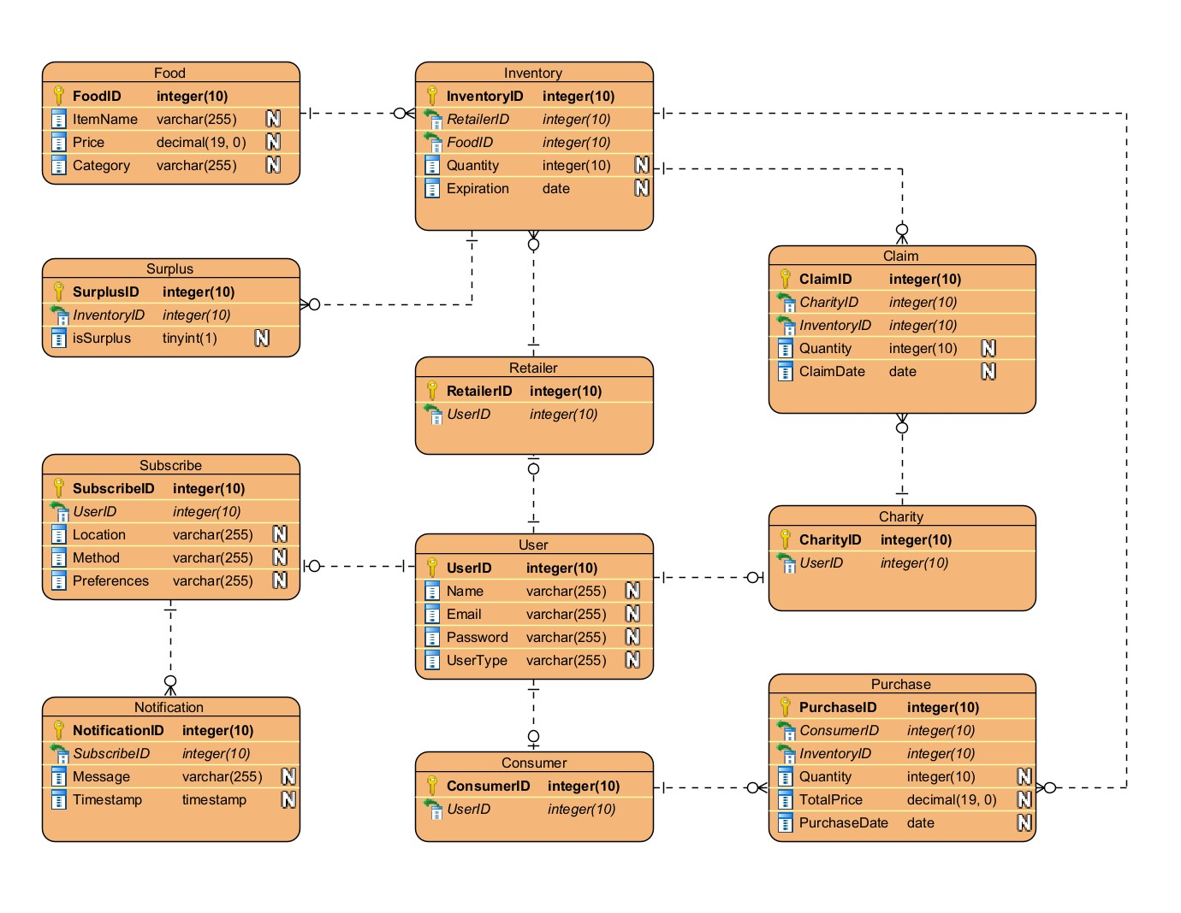

Figure 9 ERD of Food Waste Reduction System

# **9. Security Architecture**

## 9.1 Strong Password Policies

Users will be required to create passwords that meet certain complexity criteria, such as minimum length, inclusion of alphanumeric characters, and special characters.

## 9.2 Session Management

Sessions will be managed securely to prevent session hijacking and session fixation attacks.

# **10. Testing Model**

## 10.1 Testing Approach

* Unit testing using JUnit for individual components
* Integration testing for interaction between components

## 10.2 Tools

* JUnit

# **11. References**

# References

1. *What Is Session Management: Threats and Best Practices*. (2023, 07 14). Retrieved from Authgear: https://www.authgear.com/post/session-management

# **12. Acronyms/Abbreviation**

FWRP: Food Waste Reduction Platform

RDBMS: Relational Database Management System

UI: User Interface

MVC: Model-View-Controller

ERD: Entity-Relationship Diagram